**Team: UNRL**

**Member/s:** Gatal, Hao

**Overview:**

With the rapid development of contactless technology, Near Field Communication (NFC) has become a mainstream method of payment and access. In the Philippines, the growing popularity of mobile wallets such as GCash, PayMaya, and Google Pay has transformed how people conduct daily transactions, especially during and after the COVID-19 pandemic.

But here's the problem is when you use these wallet apps to pay by tapping, there’s no single place to see all your payment history. Each app keeps its own record, and sometimes, they don’t even update right away. This makes it hard for people to know if their payment went through or not. And if the payment fails, you won’t always know unless you check manually. This can be really confusing, especially if you’re using more than one wallet app.

**Solving the Problem:**

To address these issues, we propose designing a transaction history tracker application specifically focused on NFC wallet taps made on Android devices. This application will aggregate data from supported wallet apps and create a consolidated log of contactless payments performed through NFC.

We’ll do a survey with 10–20 people who use these wallet apps to understand what they find hard and what they want in this kind of app. After that, we’ll design the app and test it based on what they need.

**The Application:**

### Application Name:

**TTTAPP** (Tap-based Transaction Tracker Application)

### What it is:

**TTTAPP** is a utility tool designed to log and consolidate NFC-based wallet transactions performed on Android devices. It offers users a transparent, time-stamped view of their tap-to-pay activity regardless of the wallet app used. The application will not process payments, but instead provide a history layer that improves financial awareness and user trust.

● **Features:**

The team will have the following features incorporated into the application. Such features are as follows:

* **NFC Transaction Timeline** Displays a timeline of recent tap-based payments which will retrieve log data from supported wallets
* **App Source Identification** Shows which wallet app handled each NFC transaction (e.g., “Google Pay,” “GCash”).
* **Success/Failure Indicators** Marks transactions as "Completed," "Pending," or "Failed" based on available API feedback or user confirmation.
* **Tag Timestamp and** Each transaction will include a timestamp, transaction amount, and transaction ID
* **Privacy Lock** All history logs are protected by fingerprint or PIN access to secure financial data.
* **Offline Cache** Stores transaction logs even in offline mode, syncing once connectivity is restored.

The team will also be adding or removing features depending on the results of the Survey handed to the participants.

● **Questions about the Application:**

○ **Who are the potential users?**

Mostly Android phone users who use apps like GCash, PayMaya, and Google Pay to make contactless payments, especially students and adults who prefer cashless transactions.

○ **What tasks do they seek to perform?**

* Know if their tap-to-pay worked  
  Have a record of all their NFC payments
* Make sure they didn’t pay twice
* Be able to check their payment history without switching between apps

○ **What functionality should any system provide to these users?**

* Keep track of their payments in one easy list
* Show which app handled the payment
* Let them see the status of the payment (success/fail)
* Keep it private and easy to use

○ **What constraints will be placed on your eventual design?**

* Some wallet apps don’t allow other apps to access their data
* Not all phones may support NFC or the app
* Android rules may limit what info we can collect
* We have to make sure the app is safe and secure so people’s data is protected
* App will only work on Android, not on iPhones

○ **What criteria should be used to judge if your design is a success or not?** ■

* People can easily use it without getting confused
* They can see all their tap payments clearly and easily
* It works better or just as good as other apps like Google Wallet
* Users feel more confident about paying with their phones because they can always double-check

● **Approach:**

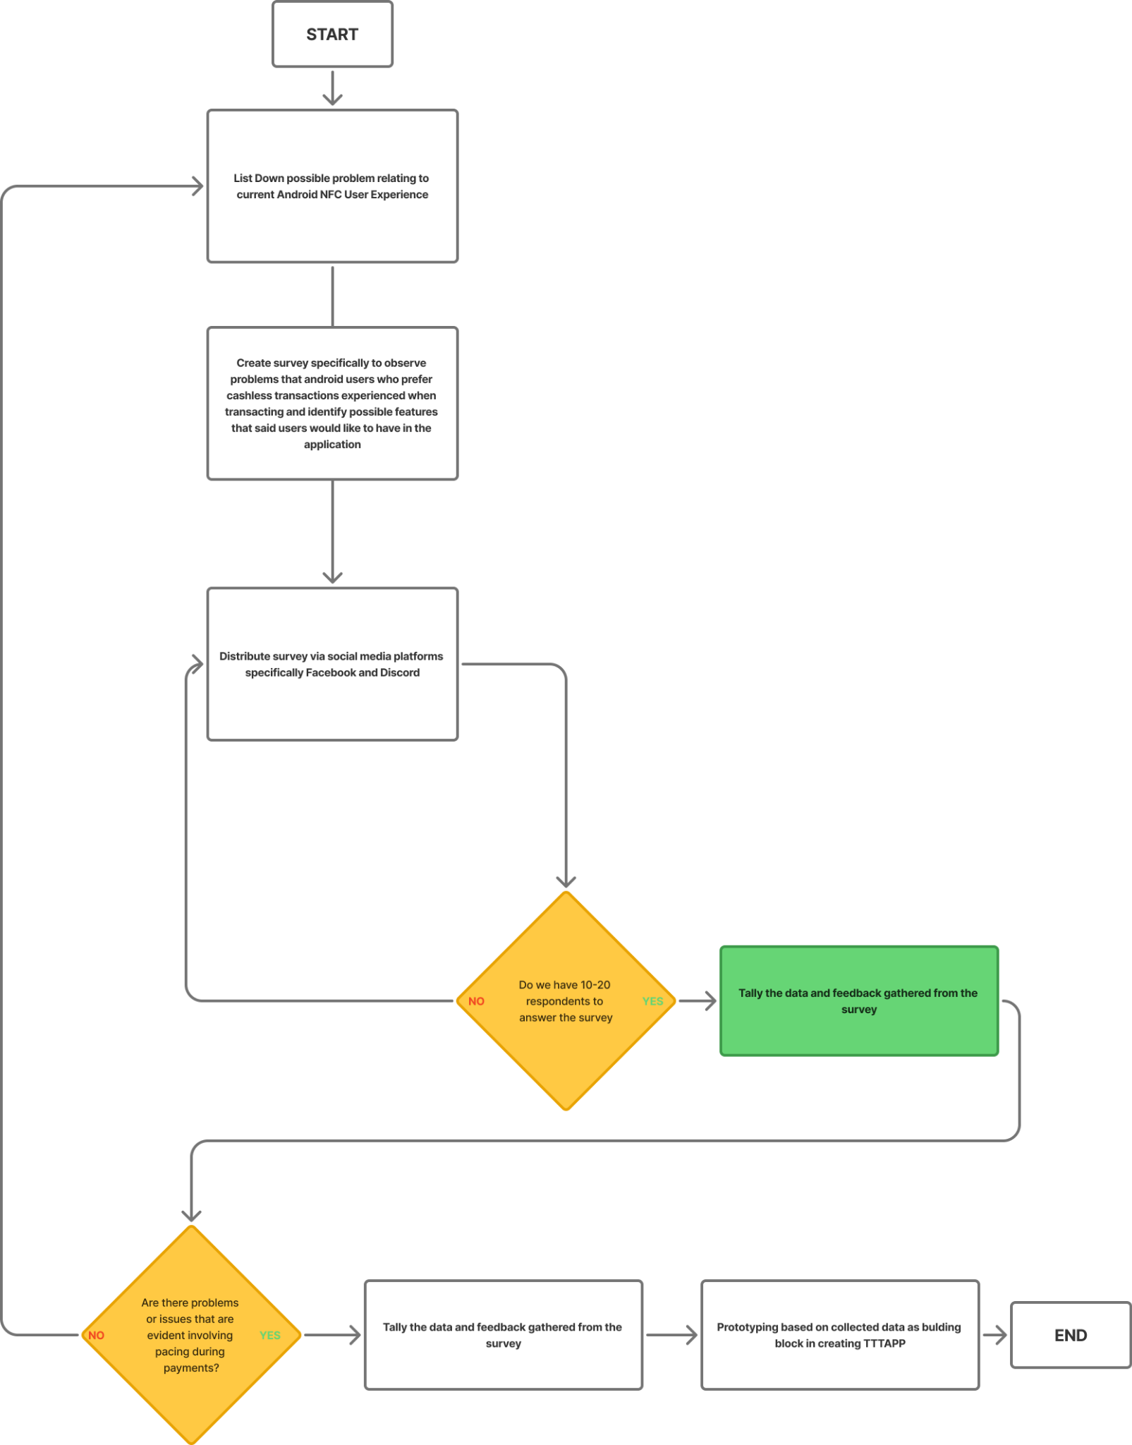

**Figure 1. Flowchart**